Start up

1. Open CMDer (or any command line/terminal application)
2. Go to “python” folder: “cd…”
3. Open jupyter notebook: “jupyter notebook”

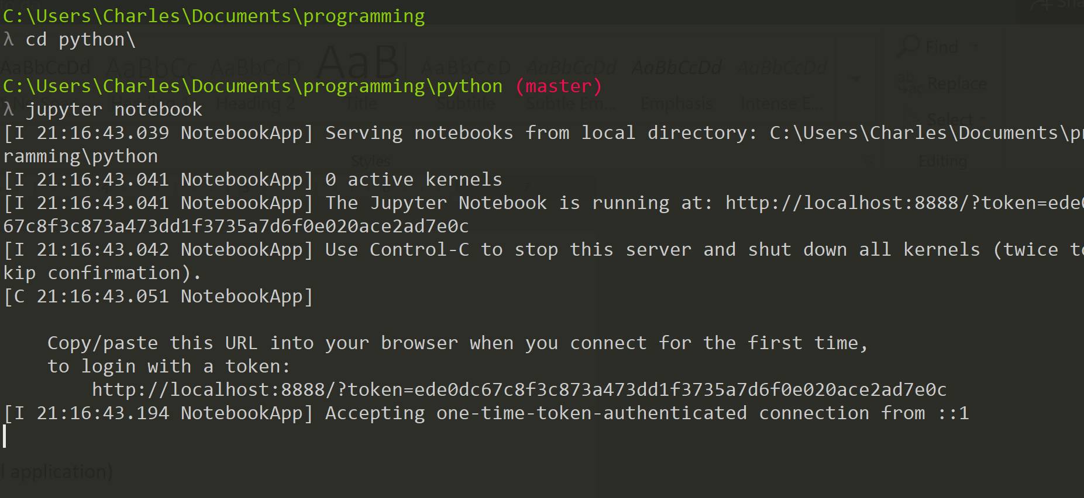

1. Jupyter notebook should launch in browser application